Canistota FCCLA Member Handbook

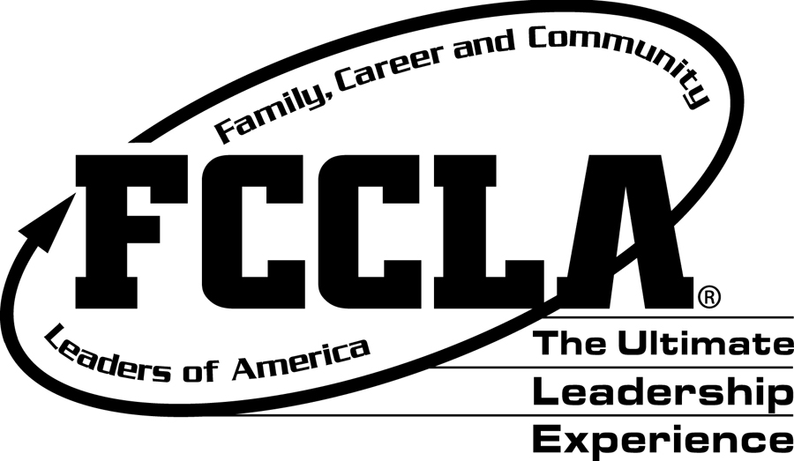

2017-2018

FCCLA OFFICERS

**HS Officers**

Student Assistant Advisor: Evan Marquardt

President: Myndi Weidenbach

Vice-President: Bree Weidenbach

Secretary: Reagen Miller

Treasurer: Cassidy Keller

Historian: Hailey Agnew

Recognition & Recreation: Payton Ortman

**Jr. High Officers**

President: Hannah Remacle

Vice-President: Saylor Hutcheson

**What is FCCLA?**

Family, Career, and Community Leaders of America (FCCLA) is a dynamic and effective national student organization that helps young men and women become leaders and address important personal, family, work and societal issues through Family and Consumer Sciences Education as determined by the state department of education. FCCLA has 200,000 members and more than 5,500 chapters from 50 state associations, Puerto Rico, and the Virgin Islands. The organization has involved more than 10 million people since its founding in 1945.

FCCLA: The Ultimate Leadership Experience is unique among youth organizations because its programs are planned and run by members. It is the only career and technical in-school student organization with family as its central focus. Participation in national programs and chapter activities helps members become strong leaders in their families, careers and communities. “Join FCCLA: The Ultimate Leadership Experience!." Join FCCLA. N.p., n.d. Web. 30 July 2014. <http://www.fcclainc.org/content/join-fccla/>.

**Advisor Expectations**

I look forward to a fantastic year for the chapter in FCCLA. This year I hope everyone has a great experience trying new activities, new projects, and meeting new people and maybe taking on new leadership roles! This year I have the following expectations for our chapter and members:

* Experience all that FCCLA has to offer
* Pick and start your projects early
* Meet all deadlines that are set
* Take responsibility for your FCCLA experience and your project
* Earn your 100 points required to attend state meeting
* HAVE FUN!!!!!

I am excited for our new year to start and want members to understand what is expected of them when they join. Students will be expected to participate in various chapter activities, meetings, and fundraising events. The students earn points for everything they participate in with FCCLA throughout the year and need to have earned 100 points to attend the state meeting in Sioux Falls in April. Students will also be expected to meet all the deadlines listed in this handbook in relation to their project. I also expect students to act professional and well behaved at all times when participating in FCCLA activities as we are representing the Canistota School District and themselves individually and do not want to present ourselves as unprofessional.

**Membership dues:**

This year our membership dues will be $22.00. The membership dues go to cover the national dues which are $9.00, $3.00 for state dues, and $3.50 for district dues which leaves $6.50 for chapter dues. We have to send in the dues to national FCCLA to have each student affiliated with the organization so they are able to compete at the district, state and national level. Once each student has been affiliated; if they decide they don’t want to be in FCCLA the dues are forfeited as they have already been paid and can’t be reimbursed.

**Chapter Goals:**

* Increase our chapter membership by 10 or more members and to be recognized at state meeting for membership increase.
* Increase the amount of community service projects to 4 as a chapter throughout the year.
* Have all members actively participate in fundraising activities so the chapter can cover the cost of State FCCLA in April.
* Require members to have 120 points from FCCLA activities to attend state meeting in April.

**Point System:**

State Officer Position 35 pts.

Region Officer 25 pts.

Local Officer/Representative 20 pts

Leadership Conference 15 pts.

Project/Event 20 pts.

Project/ Event Volunteer 15 pts.

Attend Meeting/Event 5 pts.

Small Fundraiser/event 5 pts.

Food Donation for fundraiser 5 pts.

Volunteerism 5-10pts.

Pay Dues 5 pts.

* Fundraising works towards points. Students receive 1 point per person sold to for the fundraising activity.
* Students are able to pay the full amount/cost of activities if they or their parents choose not to fundraise.
* Each student must earn 120 points in order to attend state meeting/spring conference

Ms. Knox will keep track of the points earned by each member.

**STAR EVENT/Projects**

Below is a list of star events the student may choose to participate. Some star events take much more time/thought and are more challenging than others. Students should come and talk with Ms. Knox if they have any questions on any of the star events and what is involved with each project.

STAR EVENTS:

**Advocacy**

An individual or team event, recognizes participants who demonstrate their knowledge, skills, and ability to actively identify a local, state, national, or global concern, research the topic, identify a target audience and potential partnerships, form an action plan, and advocate for the issue in an effort to positively affect a policy or law.

**Applied Math for Culinary Management**

An individual or team event, recognizes participants who use Family and Consumer Sciences skills to demonstrate the application of mathematical concepts in the culinary arts industry.

**Career Investigation**

An individual event - recognizes participants for their ability to perform self-assessments, research and explore a career, set career goals, create a plan for achieving goals, and describe the relationship of Family and Consumer Sciences coursework to the selected career.

**Chapter in Review (Display and Portfolio)**

A team event - recognizes chapters that develop and implement a well-balanced program of work and promote FCCLA and Family and Consumer Sciences and/or related occupations and skills to the community.

**Chapter Service Project (Display and Portfolio)**

A team event - recognizes chapters that develop and implement an in-depth service project that makes a worthwhile contribution to families, schools, and communities. Students must use Family and Consumer Sciences content and skills to address and take action on a community need.

**Culinary Arts**

A team event - recognizes participants enrolled in occupational culinary arts/food service training programs for their ability to work as members of a team to produce a quality meal using industrial culinary arts/food service techniques and equipment.

**Early Childhood Education**

An individual event - recognizes participants who demonstrate their ability to use knowledge and skills gained from their enrollment in an occupational early childhood program.

**Entrepreneurship**

An individual or team event - recognizes participants who develop a plan for a small business using Family and Consumer Sciences skills and sound business practices. The business must relate to an area of Family and Consumer Sciences education or related occupations.

**Environmental Ambassador**

An individual or team event - recognizes participants that address environmental issues that adversely impact human health and well-being and who actively empower others to get involved.

**Fashion Construction**

An individual event- recognizes participants who apply fashion construction skills learned in Family and Consumer Sciences courses to create a display using samples of their skills.

**Fashion Design**

An individual event - recognizes participants who apply fashion design skills learned in Family and Consumer Sciences courses to design and market clothing styles.

**Focus on Children**

An individual or team event - recognizes participants who use Family and Consumer Sciences skills to plan and conduct a child development project that has a positive impact on children and the community.

**Food Innovations**

An individual or team event - recognizes participants who demonstrate knowledge of the basic concepts of food product development by creating an original prototype formula, testing the product through focus groups, and developing a marketing strategy.

**Hospitality, Tourism, and Recreation**

An individual or team event, recognizes participants who demonstrate their knowledge of the hospitality, tourism, and recreation industries and ability to translate their knowledge into a hypothetical or real business. Project must relate to culinary, lodging, recreation, tourism, or event coordination.

**Illustrated Talk**

An individual or team event - recognizes participants who make an oral presentation about issues concerning Family and Consumer Sciences and/or related occupations. Participants use visuals to illustrate content of the presentation.

**Interior Design**

An individual or team event - recognizes participants who apply interior design skills learned in Family and Consumer Sciences courses to design interiors that meet the living space needs of clients.

**Interpersonal Communications**

An individual or team event - recognizes participants who use Family and Consumer Sciences and/or related occupations skills and apply communication techniques to develop a project designed to strengthen communication.

**Job Interview**

An individual event - recognizes participants who use Family and Consumer Sciences and/or related occupations skills to develop a portfolio, participate in an interview, and communicate a personal understanding of job requirements.

**Leadership**

An individual event, recognizes participants who actively evaluate and grow in their leadership potential. Participants use the Student Leadership Challenge and supporting materials, to investigate their leadership ability and develop a mentorship relationship to further their leadership development.

**Life Event Planning**

An individual or team event - recognizes participants who apply skills learned in Family and Consumer Sciences courses to manage the costs of an event.

**National Programs in Action**

An individual or team event - recognizes participants who explain how the FCCLA Planning Process was used to implement a national program project.

**Nutrition and Wellness**

An individual event, recognizes participants who track food intake and physical activity for themselves, their family, or a community group and determine goals and strategies for improving their overall health.

**Parliamentary Procedure**

A team event - recognizes chapters that develop a working knowledge of parliamentary law and the ability to conduct an FCCLA business meeting.

**Promote and Publicize FCCLA!**

An individual or team event - recognizes participants who use communications skills and techniques to educate their schools and communities about FCCLA with the intention of growing chapters and strengthening FACS and FCCLA programs.

**Recycle and Redesign**

An individual event - recognizes participants who select a used fashion or home apparel item to recycle into a new product.

**Sports Nutrition**

An individual or team event, recognizes participants who use Family and Consumer Sciences skills to plan and develop an individualized nutritional plan to meet the needs of a competitive student athletic in a specific sport.

**Teach and Train**

An individual event - recognizes participants for their exploration of the education and training fields through research and hands-on experience.

**STAR Event Progress**

Throughout the year the students will need to show their projects progress to Ms. Knox. By the 1st Friday of every month students will need to have shown Ms. Knox the progress they have completed on their project. If they do not meet these deadlines then they will not continue on with their project. This is down so the students are making sure their project is getting done and to make sure they are not waiting to last minute and rushing to complete their projects.

**Student/Parent FCCLA Star Event Contract**

There are many STAR Events available. Students will be expected to be responsible for contacting Ms. Knox to get help on their project and for making sure they are meeting the deadlines that are set.

**Timeline:**

|  |  |  |
| --- | --- | --- |
| **Check When Completed** | **Due Date** | **Task** |
|  | September 16th | Turn in STAR Event choice form, your Planning Process for event (only the first three steps are to be completed now), and signed STAR Event agreement |
|  | October 14th | Project progress check |
|  | November 10th | Project progress check |
|  | December 9th | Project progress check |
|  | November 28th | Present Illustrated Talk to adviser  Present Job Interview binder to adviser and practice the interview |
|  | December 7th | All Illustrated Talks and Job Interviews Events will be presented at the region meeting.  All members planning to attend the state meeting are required to attend the region meeting. |
|  | January 13th | Project progress check |
|  | February 10th | Project progress check |
|  | March 10th | Final project progress check |
|  | March 20th | Present STAR Event to adviser (This includes Illustrated Talks and Job Interviews which will be advancing to state) |
|  | March 24th | Present STAR Event at *Community FCCLA Night* |
|  | April 8-10 | State Leadership Meeting in Sioux Falls |
|  | June 28th-july 2nd | National Leadership Conference in Atlanta, Georgia |

1. I will be doing the STAR Event:(name of star event)

_______ As an individual _______ With the following members __________________

1. I have attached the Planning Process for this event (only the first three steps need to be completed).
2. I have read the information below, have signed it, and have had my parent(s)/guardian sign it.

**Agreement:** I understand that if I do not present the Star Event at the state meeting, I am responsible for reimbursing the chapter or school for the following:

* + Materials used
  + Registration fees and housing costs for state meeting
  + Region meeting cancellation fee

_______________________________________________________ ____________________________

(Member Signature) (Date)

_______________________________________________________ ____________________________

(Parent/Guardian Signature) (Date)



_______________________________________________________ ____________________________

(Administration Signature) (Date)

**Thoughts**

1. Read the rules!
2. The rules can **change** from year to year.
3. Begin early.
4. An Illustrated Talk is a good start for your **first** STAR Event.
5. Doing a STAR Event with a partner can be fun, **but** can your schedules coincide? Do you have the same goals?
6. File folder information goes on the top left, **no matter** where the tab is.
7. Follow the proper procedure for the bibliography – this is **not** the place to be creative.
8. Make sure that hair is not in face.
9. Strive for a professional appearance.
10. Wear closed toed shoes (avoid sandals).
11. A personal experience can be a good topic choice for an Illustrated Talk.
12. If used, note cards should contain notes, rather than the entire presentation written out word for word, as then the tendency is to read from the note cards.
13. PowerPoint versus posters for Illustrated Talk…….

**PowerPoint**

* May be quicker to create than posters
* Sometimes computers freeze
* Sometimes the computer “dies” (power is not supplied)
* Best to put only one large graphic on each slide
* Best to limit the number of words on each slide
* Judges must be able to see the slide, recognize the graphic and read the words
* Presenter must **use** the visuals during the presentation
* Remember that props may be used in addition to slides

**Posters**

* Use a straight edge to insure that letters are positioned correctly
* Keep posters protected to keep them clean and to keep corners straight
* Make sure graphics are large enough so that judges can see them
* Avoid putting too many graphics on the poster
* Arrange posters so that the next one is pulled from the back
* Remember that props may be used in addition to posters

1. Best wishes and have fun!

**Consequences**

* If students do not earn 120 points then they will not be attending state meeting. This is done to make sure all members are participating and earning their way to the state meeting.
* If students do not meet the deadlines they will not be attending region and or state meeting. By setting these deadlines the students should be working on their projects throughout the entire semester and not starting their projects later and rushing to finish them right before the meeting. If students do not meet these deadlines and have already been registered then they will have to reimburse the Canistota FCCLA chapter the money for registration, housing, and/or for materials used.
* If a student is behaving unprofessionally/inappropriately the student will not be allowed to participate in FCCLA activities until they can behave in a respectful manner and represent Canistota School in an appropriate manner adhering to the respectful behavior expectations in the school handbook.